

**Submitted by: Bilal Ahmed**

**Reg no: 4745-FOC/BSSE-F23**

**Section: A**

**Course: Introduction to Database**

**Submitted to: Mr. Shakir Rasheed**

**Topic:**

**ERD**

**(Entity Relationship Diagram)**

An Entity Relationship Diagram (ERD) is a visual representation of the data and relationships in a database system. It helps to identify how different entities (objects or concepts) interact with one another. ERDs are used during the database design process to ensure data is organized efficiently, relationships are clear, and redundancy is minimized.

**PET ADOPTION CENTRE**

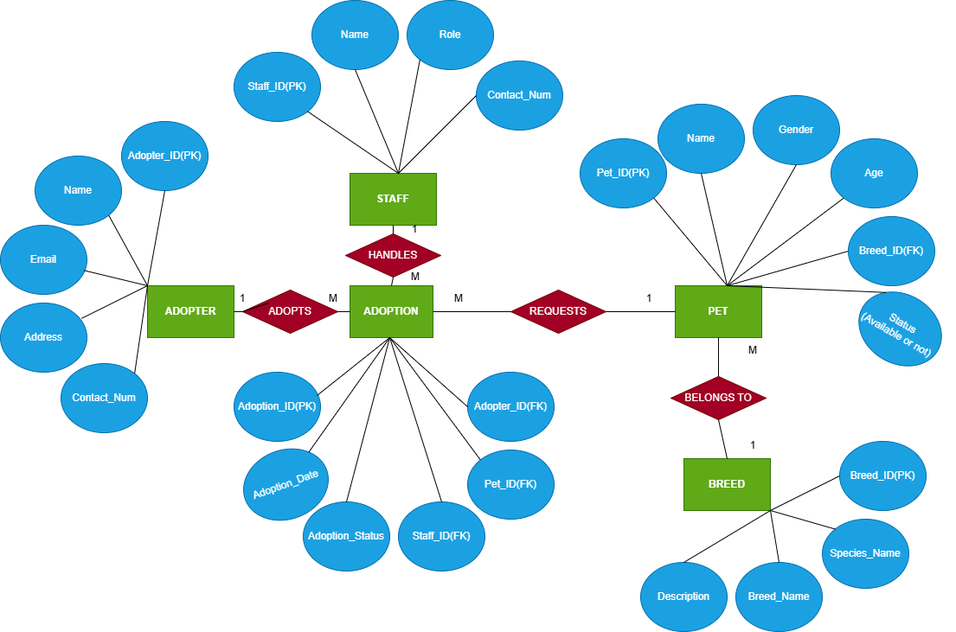

**Summary:**

The Pet Adoption Centre database system is designed to manage the process of adopting pets efficiently. It stores information about adopters, pets, staff, and animal breeds, along with adoption transactions. Each adopter can adopt one or more pets, and every adoption is supervised by a staff member. Each pet belongs to a specific breed and can be adopted once. The ERD demonstrates the relationships among entities using primary and foreign keys to ensure data consistency and integrity. This system allows tracking of available pets, managing adopter details, and monitoring adoption activities handled by the staff.